**Anthony Sturdy FOGGS Semester 2 Report**

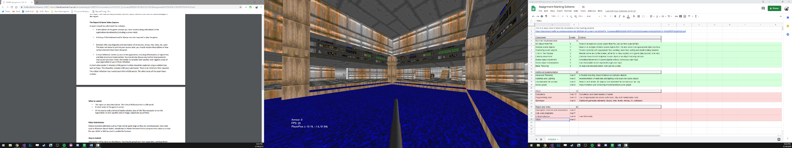The 3D scene I created is of Doom’s E1M1 map. You can walk around the level, there is collision, gravity, armour pickups and you walk with a shotgun. The level is fully textured (except for one in-accessible secret area) and has a skybox. The armour pickups and gun all have lighting enabled on them, the level doesn’t have lighting enabled. The collision used a separate mesh for navigation, which determines where the player can walk and the height of the floor the player is currently standing on.

**Controls**

WASD – Movement

Shift – Sprint (Have to hold shift *then* press movement button)

Caps lock – Toggle sprint (Have to press caps lock *then* press movement button)

Mouse – Look around

Escape – Exit

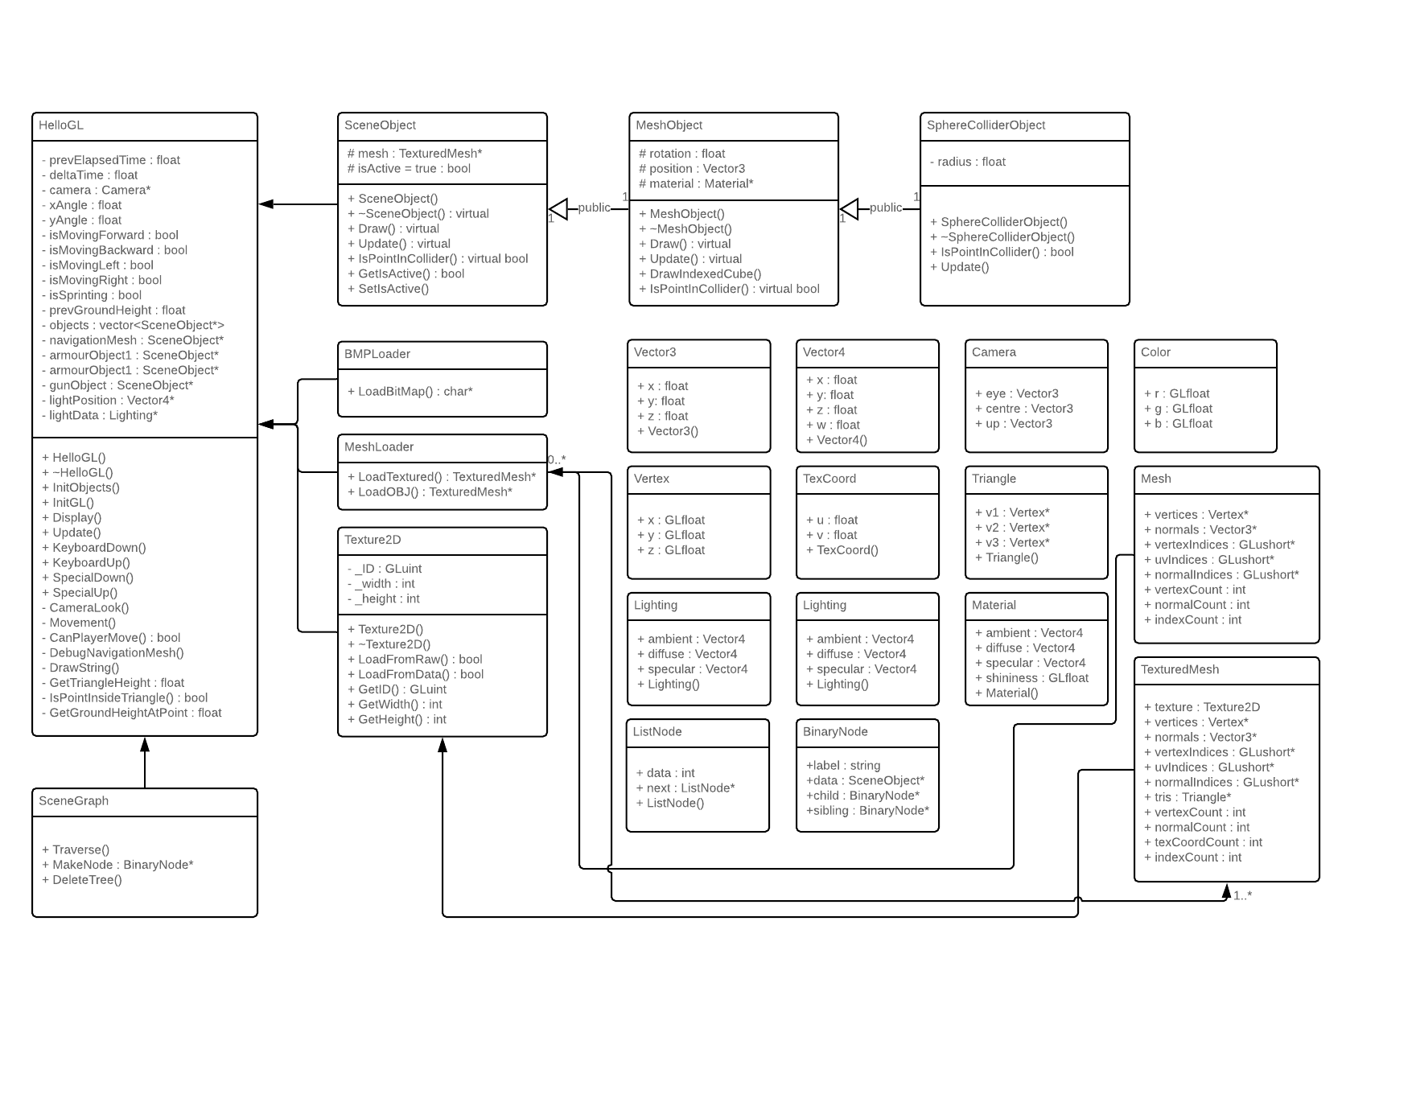**UML Class Diagrams**

**Critical Reflection**

In my opinion I have made good progress with the application, although I think it could have more functionality if I had more time or knowledge. I think what went well, was the getting the level model rendered and textured fully. The model is textured with one 2048x2048 texture, the model is UV mapped to use parts of the texture it needs for each triangle.

The gun and armour pickups have lighting enabled on them, to improve this I could have lighting on the whole level with shadow mapping, although when researching this, I realised it would probably take me a long time to implement as it seems very complex. I would like to apply more advanced lighting to future projects when I know more about 3D rendering.

The UI could also be improved as it is quite simple at the moment. I would like to have implemented the original Doom UI bar, as I think it would be a big improvement to the scene. UI is something I would like to research more in the future, as it is an important part of making a game/game engine. At the moment the UI does not stand out well at all, and is mainly used for displaying information about the game which would not be shown if in a proper game (apart from the armour).

The collision system worked well for this application. The application uses a navigation mesh to decide where the player can walk, check if the player tries to go ‘out of bounds’ (hit a wall) and get the height of the floor (so the player can walk up and down stairs, drop off ledges, etc). The navigation mesh has allowed the movement feel a lot like the original doom. Although the navigation mesh is great for this scene, it might not work as well in other games which require more player freedom when moving around the level.

There is also a BMP loader implemented for textures, and an OBJ loader for 3D models. They both work great, but I feel could be improved. The BMP loader can only load 24 bit BMP files, and the OBJ loader can only load meshes split into triangles, many models I downloaded online for testing used quads, meaning they had to be converted to triangles. This was not a problem for a small application like this, but if the project was bigger it would be good to add support for these files. If it needed to support transparency on textures, it would also need to be able to load 32 bit BMP’s.

In conclusion, the scene is a good start and introduction for me into 3D rendering. I have learnt many concepts which will be useful for future projects, and believe I would be able to improve future applications from the experience I have gained developing this.